Second Synopsis
On
Online Recruitment System

Submitted To: Submitted By:
Mrs. Mini Singh Ahuja Name: - Sahil Mahajan
Roll No. : - 2010CSA1743

Department of Computer Science and Engineering
Guru Nanak Dev University, Regional Campus, Gurdaspur
Table of Contents

Sr. No. | Topic | Page No.
 | Organization Profile | 3
 | Front End | 4-5
 | Back End | 6
 | Hardware & Software Requirements | 7
 | Project Description | 8
 | Data Flow Diagrams | 9-12
 | ER-Diagrams | 13-14
 | Database Tables | 15-17
 | Project Snapshots | 18-21
 | Bibliography | 22

ORGANIZATION PROFILE

VMM Education:

VMM Education provides world class training in global technologies such as .Net and Linux, while keeping our syllabus up to date with the current industry standard. We have managed to successfully train more than 7000 engineers who are currently working in Global Multinationals like TCS, Tech Mahindra, Infosys etc.

Attendance of students is one of the major features of VMM, students are required to record their day to day attendance using Biometric Finger-print Recognition device. This allows us to provide accurate attendance of students to their parents and college during their training time
.
Six Months Industrial Training
Doing your six months industrial training at VMM is a very special experience for any engineering graduate as it allows the students to nurture his / her of knowledge by working on Technologies like ASP.Net, Silverlight, AJAX, Java, Android etc. The candidate is required to spend almost whole day at institute doing their Lab practical or attending their tutorial lecture and developing a project which they can submit in their college as a part of dissertation.


Front End : JAVA AND ANDROID
Java :-
Java is a general purpose and the most popular object-oriented programming language. Java was developed by James Gosling and his colleagues at Sun Microsystems in the early 1990’s.
Due to its simplicity and easy to learn and advanced features, we opted this language for our six months industrial training. This language supports many interesting features that make it an ideal language for software development. In addition to the object oriented features, it also provides features such as platform independence, security, multithreading, portability; etc which makes it well suited for the web and networked services, applications, platform-independent desktops, robotics and any other embedded devices.
Features of Java:
- Simple
- Object-oriented
- Distributed
- Robust
- Secure
- Architectural Neutral
- Portable
- Interpreted
- High performance
- Multithreaded
- Dynamic

Android :-


Android is a software stack for mobile devices that includes an operating system, middleware and key applications. The Android SDK provides the tools and APIs necessary to begin developing applications on the Android platform using the Java programming language.
Features
- Application framework enabling reuse and replacement of components
- Dalvik virtual machine optimized for mobile devices
- Integrated browser based on the open source WebKit engine
- Optimized graphics powered by a custom 2D graphics library; 3D graphics based on the OpenGL ES 1.0 specification (hardware acceleration optional)
- SQLite for structured data storage
- Media support for common audio, video, and still image formats (MPEG4, H.264, MP3, AAC, AMR, JPG, PNG, GIF)
- GSM Telephony (hardware dependent)
- Bluetooth, EDGE, 3G, and WiFi (hardware dependent)
- Camera, GPS, compass, and accelerometer (hardware dependent)
- Rich development environment including a device emulator, tools for debugging, memory and performance profiling, and a plugin for the Eclipse IDE
Back End
MySQL


MySQL is a open source Relational Database Management System. MySQL is very fast reliable and flexible Database Management System. It provides a very high performance and it is multi threaded and multi user Relational Database management system.
MySQL is one of the most popular relational database Management System on the web. The MySQL Database has become the world's most popular open source Database, because it is free and available on almost all the platforms. The MySQL can run on Unix , window, and Mac OS.

HARDWARE REQUIREMENTS:
Hardware requirements include that hardware which is required for its working. It includes:
- Pentium 4 Computer
- 512 MB RAM (Minimum)
- High Speed Internet Connection
- Any Smartphone with Android API 2.3 or 4.0


SOFTWARE REQUIREMENTS
The technical specifications of requirements for the software are as follows:
- Any Operating System (Windows, Linux, MAC)
- Java run time environment
- Netbeans (Java IDE)
- Java SDK (Software Development Kit)
- Android Development Toolkit (ADT)
- Any web browser(Chrome , Firefox , etc)

PROJECT DESCRIPTION

Project Name

Online Recruitment System

Objective

Platform to facilitate the interaction between Recruiter and Aspiring students for effective hiring process on the part of both Employee and Employer. Web and mobile based platform to provide opportunities to unplaced and placed candidates and a hassle free tool for Recruiters to boost up their recruiting process, in order to benefit both ends.

Features of the Project
- Sign up and Login for Recruiter and Aspiring Employee.
- Automatic Resume generation and forwarding from credentials entered by student.
- Online mock test for Aspiring Students and result display at websites for recruiters to access.
- Mobile Application on Android platform for both Registered Recruiter and aspiring candidates for potable access to main website.
- Company profiles of different companies and their portfolios for Registered Candidates to access.

Level 0 DFD for Online Recruitment System

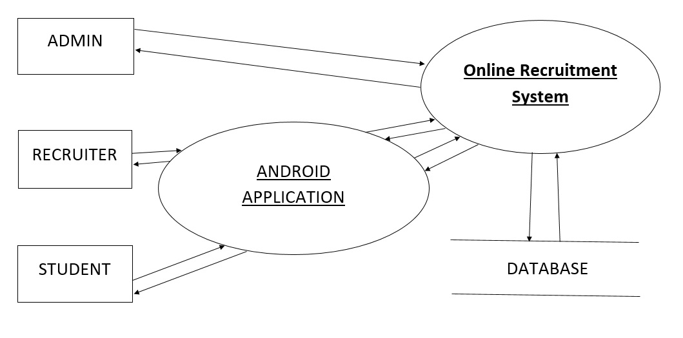

Level 1 DFD for Administrator Side

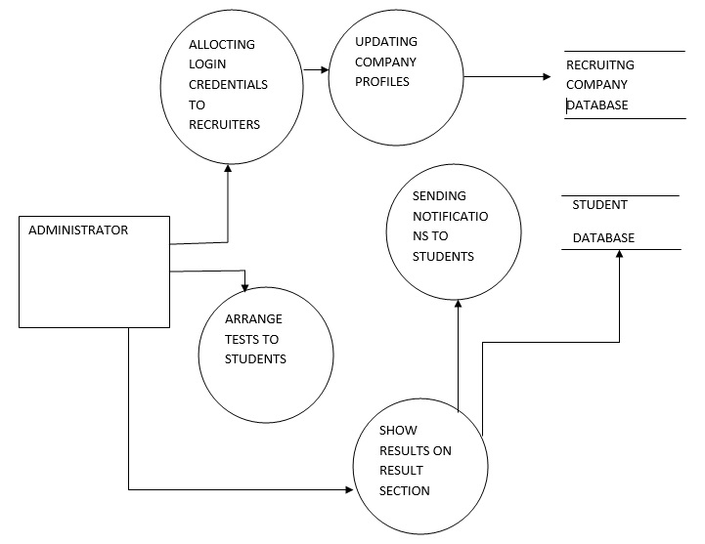

Level 1 DFD for Recruiter Side

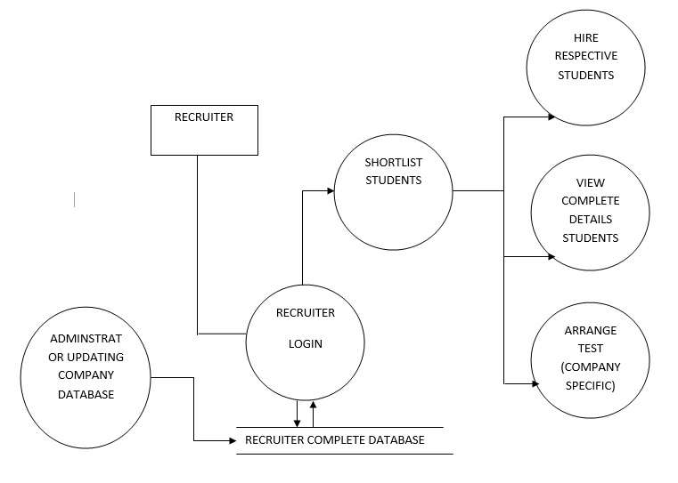

Level 1 DFD for Student Side

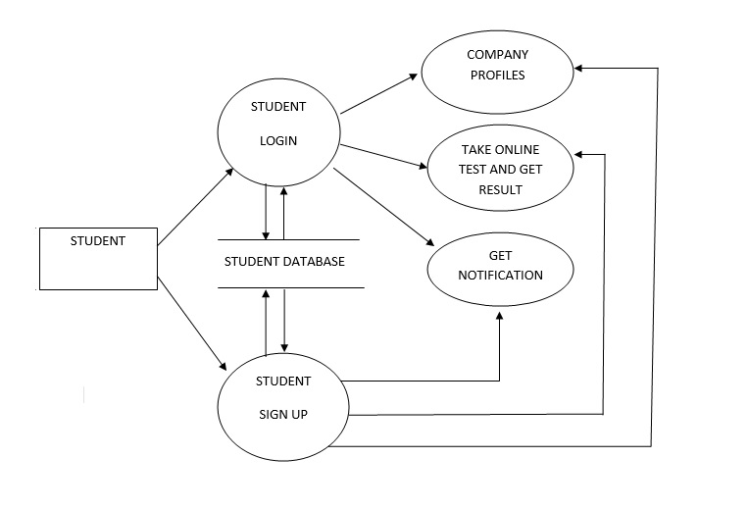

ER-Diagrams for Online Recruitment System

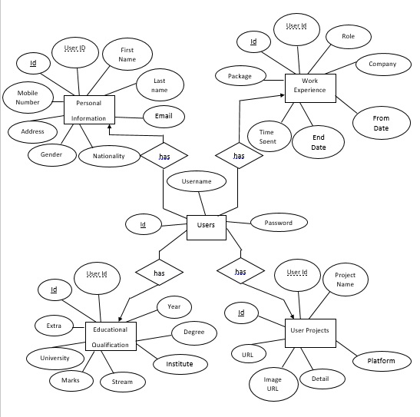

ER-Diagrams for Online Recruitment System

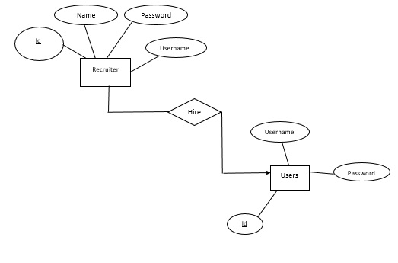

Database Tables for Online Recruitment System

- Recruiters
FIELD | DATATYPE | CONSTRAINTS | DESCRIPTION
Id | INT | Primary key | Store Auto Generated ID
Username | VARCHAR(45) | Not Null | Store username given to each recruiter
Password | VARCHAR(45) |  | Store password of each recruiter
Name | VARCHAR(45) |  | Store name of each recruiter

- Users
FIELD | DATATYPE | CONSTRAINTS | DESCRIPTION
Id | INT | Primary key | Store Auto Generated ID
Username | VARCHAR(45) | Not Null | Store username given to each user
Password | VARCHAR(45) |  | Store password of each user

- Personal Information
FIELD | DATATYPE | CONSTRAINTS | DESCRIPTION
Id | INT | Primary key | Store Auto Generated ID
User Id | INT | Foreign key | Store unique id given to each student
First Name | VARCHAR(45) |  | Store First name of student
Last Name | VARCHAR(45) |  | Store Last name of student
Email | VARCHAR(45) |  | Store e-mail id
Nationality | VARCHAR(45) |  | Store Nationality
Gender | CHAR |  | Store Student Gender
Address | INT |  | Store Address
Mobile Number | NUMERIC(12,0) |  | Store Phone Number

- User Projects
FIELD | DATATYPE | CONSTRAINTS | DESCRIPTION
Id | INT | Primary key | Store Auto Generated ID
User Id | INT | Foreign key | Store unique id given to each student
Project Name | VARCHAR(45) |  | Store Role of User
Platform Used | VARCHAR(45) |  | Store name of Company
Details | DATE |  | Store Joining date from ex-company
Image URL | DATE |  | Store Resignation date from ex-company
URL | NUMERIC(3,3) |  | Store Total Time Spent
Package | NUMERIC(10,5) |  | Store Package

- Work Experience
FIELD | DATATYPE | CONSTRAINTS | DESCRIPTION
Id | INT | Primary key | Store Auto Generated ID
User Id | INT | Foreign key | Store unique id given to each student
Role | VARCHAR(45) |  | Store Role of User
Company | VARCHAR(45) |  | Store name of Company
For Date | DATE |  | Store Joining date from ex-company
End Date | DATE |  | Store Resignation date from ex-company
Time Spent | NUMERIC(3,3) |  | Store Total Time Spent
Package | NUMERIC(10,5) |  | Store Package

- Education Qualification
FIELD | DATATYPE | CONSTRAINTS | DESCRIPTION
Id | INT | Primary key | Store Auto Generated ID
User Id | INT | Foreign key | Store unique id given to each student
Year | YEAR |  | Store Year of passing
Degree | INT |  | Store Details of Degree
Institute | INT |  | Store Details of Institute
Stream | VARCHAR(45) |  | Store Degree of Specialization
Marks | NUMERIC(3,3) |  | Store Marks of Degree
University | INT |  | Store name of University
Extra | VARCHAR(45) |  | Store any extra detail about him/her self
Screen Shots for Online Recruitment System

- WebEnd: 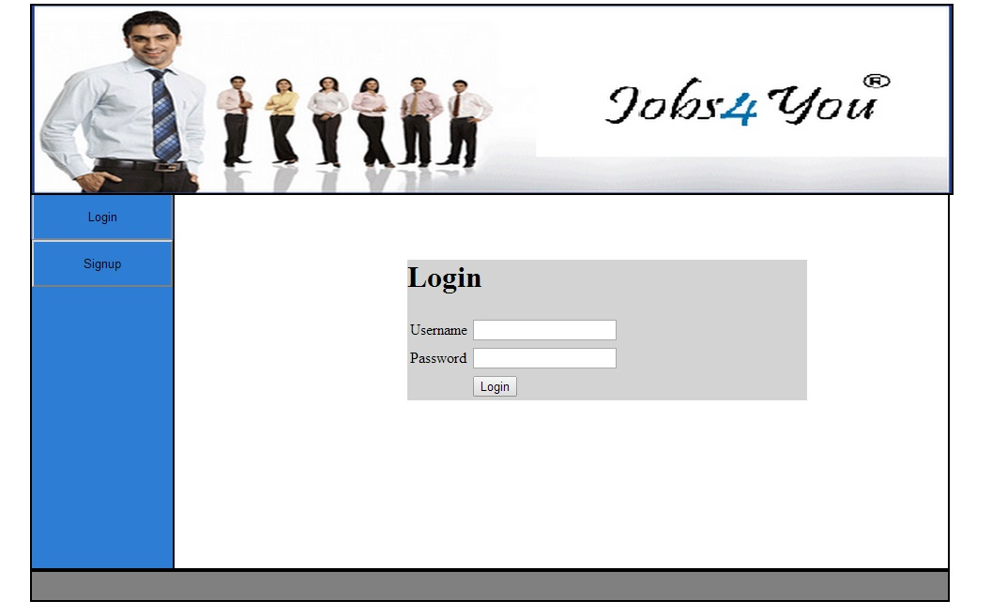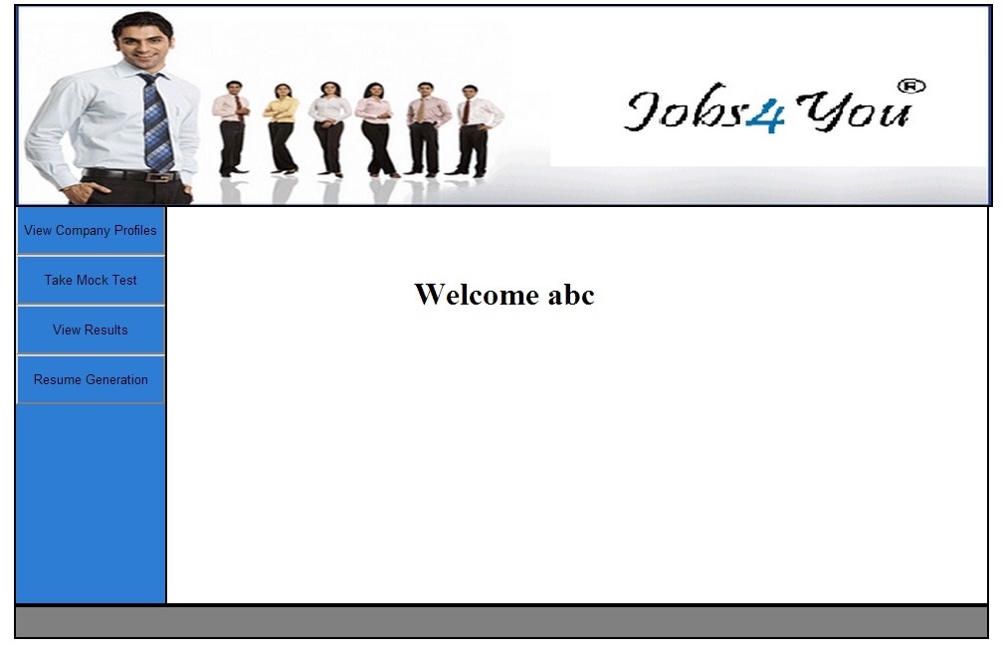
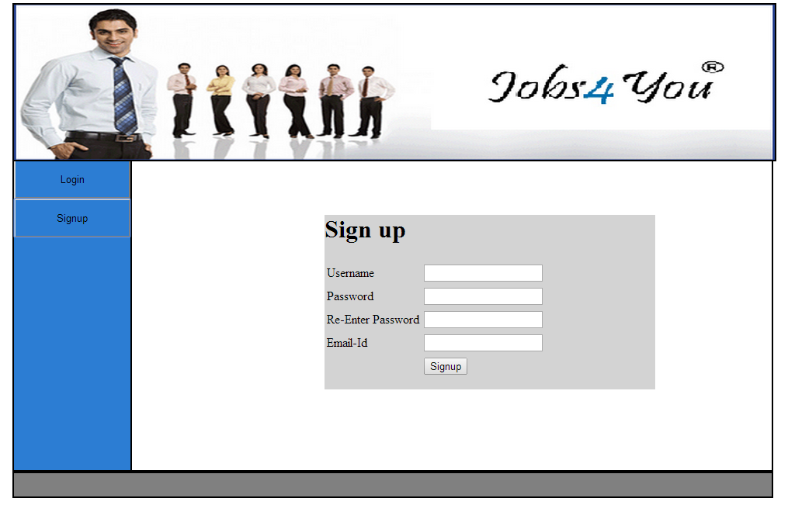

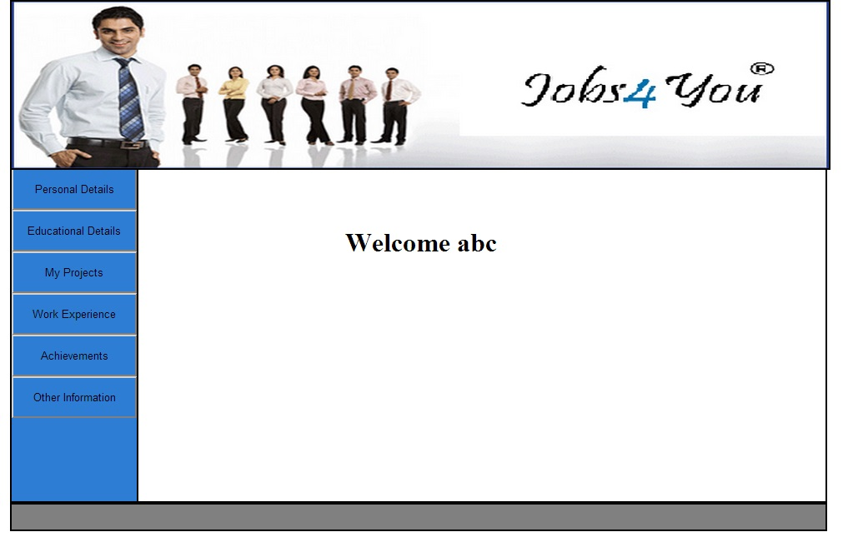

- Android App End
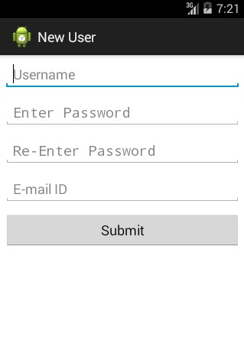
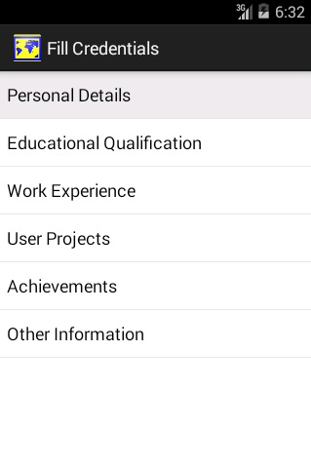
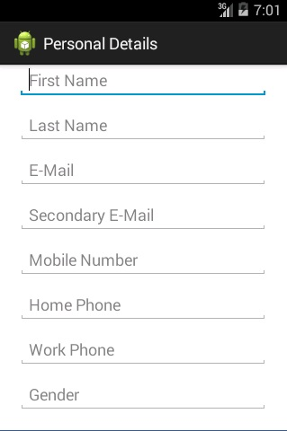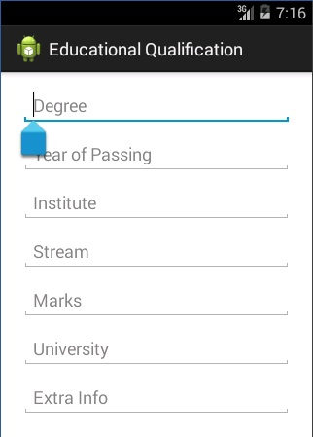

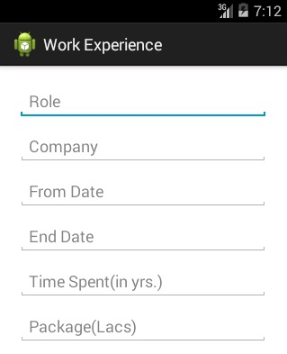

Bibliography:
Books
- The Complete Reference – Java, J2SE By Herbert Schildt
- Programming with Java By E. Balaguruswamy
- Database Management System By Parteek Bhatia

Websites
- www.wikipedia.org
- www.developer.android.com
- www.ebooks.com
- www.oracle.java.com
- www.w3schools.com

